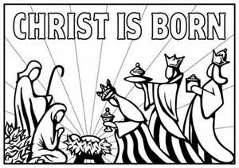
Christmas Flowers and Memorial Gifts 2022
Poinsettias
Bernadette & Skip Galayda in memory of Margaret & John Galayda
Jen Egan in memory of Florence Howes
Miss Laureen in honor of our Sunday School students
The Gworek Family in memory of Mildred & Albert Bassett and Ted & David Gworek
Sharon Kupiec in memory of the Parker and Sloat Families
Shirley Mason in memory of the Adams-Mason Families
Bill & Barbara McKay in honor of our grandchildren with love
Nikolaus and Stefan Paneczko in memory of Judith F. Barrows
Margaret Shigo-Zembko in memory of Steve Zembko and John & Elizabeth Shigo
Gifts
Barbara Adams in memory of Horace Adams
In memory of Ron – Love, Lee
Barbara Burkhardt in loving memory of her beloved husband and son, Ernie Burkhardt Jr. and Ernie “Chip” Burkhardt III
Ginni Butler in loving memory of Gert & Ken Butler
Bill & Barbara McKay in memory of our loving parents
Michel grandchildren & great-grandchildren in loving memory of Lucy & Bob Lee and Addie & Bill Michel
Betty Porter & Family in memory of Emma & John Haskell, Alma & Ken Porter, and Warren Porter

