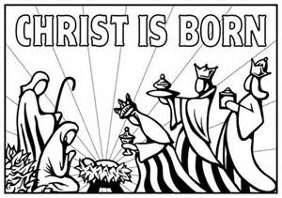
Christmas Flowers and Memorial Gifts 2021
Poinsettias
Burkhardt family in memory of Ernie Burkhardt Jr. and Ernie “Chip” Burkhardt III
Marvin Choquette in memory of Vincent & Fern Choquette
Jean Cook in memory of Laurie Cook
Bernadette & John Galayda Jr. in memory of Margaret & John Galayda Sr.
Laureen Galayda in memory of Margaret & John Galayda and Ada Larkins
Gworek family in memory of Al & Mildred Bassett and Ted & David Gworek
Gene Hilton in memory of loved ones
The Morning Glories in memory of Margaret Lemanski
Peg in memory of Margaret & Doug Lewis
Shirley Mason in memory of the Adams and Mason families
Bill & Barbara McKay in memory of our parents with love
Bill & Barbara McKay in honor of our dear grandchildren with love
The Olore family in memory of Dr. & Mrs. Louis Olore, Edward Schellhammer, and Brandon Stallworth
In memory of Skip Parker given by his wife
Art Sr. & Mildred Pugh in memory of Art Pugh Jr.
Margaret Shigo-Zembko in memory of Steve Zembko and John & Elizabeth Shigo
Phyllis Wade in honor of and in memory of loved ones
Gifts
In memory of Ron – Love, Lee
Burkhardt family in memory of Ernie Burkhardt Jr. and Ernie “Chip” Burkhardt III
Ginni in loving memory of Gert & Ken Butler
Michel family in memory of Lucy & Bob Lee with love
Betty & Warren Porter in memory of Emma & John Haskell and Alma & Ken Porter
Shaw family in loving memory of Al Shaw

