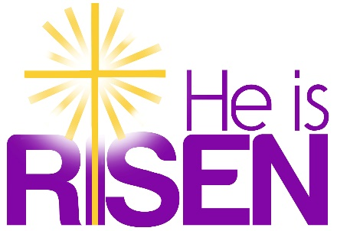
Easter 2024
Thank you to everyone who gave flowers and/or gifts in honor or memory of someone special for the Easter season.
Flowers
Kathy and Martha in memory of loved ones
Lorraine Chubet and Barbara Aszklar in memory of Lena Dow
Marvin Choquette in memory of Vincent & Fern Choquette
Jean Cook in memory of Lori Cook
Sarah Gadarowski in honor of Deborah Zembko and Margaret Zembko
Laureen Galayda in memory of loved ones
Skip & Bernadette Galayda in memory of Margaret & John Galayda
The Gworek family in memory of Albert & Mildred Bassett and Ted & David Gworek
Jennifer A. Howes in memory of Florence M. Howes and Maurice H. Howes
Sharon Kupiec in memory of the Sloat and Parker families
Peg Lewis in memory of Margaret Orr Lewis
Bill & Barbara McKay in honor of our grandchildren with love
Robin Michel in loving memory of Lucy & Bob Lee and Addie & Bill Michel
The Neilsons in memory of MaryAnn and Wilda
The Olore family in memory of Brandon Stallworth, Dr. & Mrs. Louis Olore and Edward Schellhammer
Margaret Shigo-Zembko in memory of Stephen Zembko and John & Elizabeth Shigo
Shirley Mason in memory of the Adams and Mason families
Nikolaus and Stefan Paneczko in memory of Judith F. Barrows
Diana Raymond, Tony Arisco in memory of Alice Bogue, Al Raymond and Angie Arisco
Cheryl Tomkiewicz in memory of my mom, dad, sister and aunt
Phyllis in memory of Willie “Bobby” Wade and my siblings David, Sidney, Charles, Barbara & Ora

Gifts
Barbara Adams in memory of Horace Adams
Barbara Burkhardt in memory of Ernest Burkhardt Jr. and Ernest “Chip” Burkhardt III
In memory of Ron, Love, Lee
Ginni in loving memory of Gert and Ken
Sarah Gadarowski in honor of Deborah Zembko and Margaret Shigo-Zembko
Laureen Galayda in memory of loved ones
Peg Lewis in memory of Margaret Orr Lewis
Bill & Barbara McKay in memory of our beloved parents
Jean McKay in memory of my loved ones
Robin Michel in loving memory of Lucy & Bob Lee and Addie & Bill Michel
Nikolaus and Stefan Paneczko in memory of Judith F. Barrows
Betty Porter and family in memory of John W. & Emma Haskell, Ken & Alma Porter, and Warren Porter

